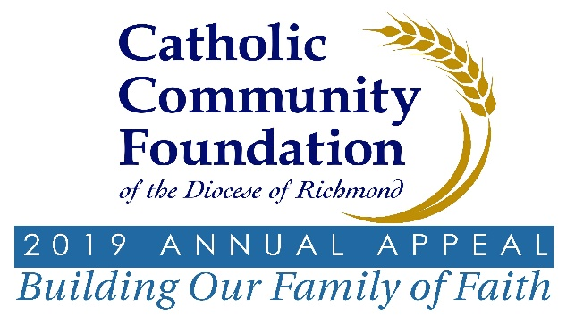

2019 Annual Appeal – Case for Support
Supplementary Information/Statistics on Select Case Elements

Advancing Social Justice

Fuel & Hunger Fund

- The Annual Appeal funding of the Fuel & Hunger Fund has been essential in helping our parishes and Catholic organizations provide additional support for those in need. In 2018 grants totaling $256,200 were distributed to 81 parishes and Catholic organizations.
Saint Francis Home

- This year the Appeal, for the first time, is providing funding to this ministry serving seniors and disabled adults who have little or no means of income. Although the facility is based in Richmond, residents come from all regions of Virginia. To learn more about their work, visit www.saintfrancishome.com
Hispanic Ministry

The Appeal is helping the Office of Hispanic Ministry grow the following ministries:
- Empower our volunteer parish ministry leaders (intercultural)
- Enhance certificate programs and provide additional workshop opportunities
- Provide outreach ministry (Women’s & Men’s Conferences)
- Build a Migrant Ministry Program
Segura Initiative

Thanks to the Annual Appeal, the following schools have the benefit of a Segura Advocate.
- All Saints, Bishop Sullivan, Blessed Sacrament, Charlottesville, Christ the King, Our Lady of Lourdes, Our Lady of Mt. Carmel, Peninsula, Portsmouth Regional, Roanoke, Sacred Heart, St. Ann, St. Mary Star of the Sea, St. Benedict, St. Bridget, St. Edward-Epiphany, St. Gregory the Great, St. Joseph, St. Mary, St. Matthew, St. Pius, St. John the Apostle, Star of the Sea
Cultivating Catholic Leadership

Seminarian Education

- The Diocese currently has 30 men in various phases of preparation for the priesthood. The cost to educate one seminarian is approximately $50,000 per year which includes room & board, tuition and health insurance. A significant portion of this cost is funded by the Annual Appeal.
Lay Ecclesial Ministry Institute (LEMI)

There are some new developments in this quickly growing ministry thanks to support from the Annual Appeal:
- Began application process for a new 2019 LEMI class (10 graduate students, 2 Dayton Certificate students).
- Started process for review of certification standards and procedures by the USCCB Subcommittee on Certification for Ecclesial Ministry and Services
- Explore expansion of LEMI to address formation needs of lay ministry leaders serving in non-catechetical roles, e.g. parish business managers, worship/music ministers and those involved in social service
- Continue to develop new partnerships with accredited Catholic universities to enable greater tuition savings
Campus Ministries

Among the many campus ministry programs being supported through the Appeal, here are some of the highlights:
- Diocesan College Summit
- Diocesan College Women’s Retreat
- Transition Program for High School Seniors to College Freshman
- Expansion of Campus Ministry to Community Colleges & New Campuses/Program Dev.
- Fellowship of University College Students – Leadership Initiative – JMU, VT and UVA
Youth and Young Adult Ministries

The following programs receive support from the Annual Appeal:
- Diocesan Youth Conference
- Diocesan Work Camp
- Youth Workers Training Support
- Local Regional/Parish Support of Youth Programs (Southwest Retreat)
- Scholarships for Diocesan Programs (Discovery/CA, Steubenville Retreat, etc.)
- Diocesan Vocations High School Retreat for Young Men (Quo Vadis)
- Diocesan Vocations High School Retreat for Young Women (Fiat Days)
- Diocesan Men’s Conference
- Diocesan Women’s Conference
- Young Adult Retreat Programs
- Young Adult Mission Week in Wise County
- Theology on Tap Programs
- Young Adult Leadership Training Programs
- Young Adult Support/Resources for Parishes
- Young Adult Parish JumpStart Program
Evangelization

The Appeal is helping the Office for Evangelization redouble its efforts to move significant evangelization forward across the 33,000 square miles of our Diocese by aiding in the following areas:
- Evangelization Training Program for Parish Staff and Leaders
- Evangelization Materials and Resources for Parishes
Center for Marriage, Family, and Life

The core of the mission of the Center for Marriage, Family, and Life is aided in-part by the Annual Appeal. Here is how funding from the Appeal is being put to use in this ministry:
- Marriage Preparation Support
- -- FOCCUS/Prepare/Enrich Facilitator Training
- -- Marriage Preparation Certification Program
- -- Diocesan Marriage Workshop for New Priests and Deacons
- Marriage Enrichment and Natural Family Planning (NFP)
- -- Enrichment Programs (Prepare & Enrich, Art of Marriage, 10 Great Dates)
- -- Retrouvaille
- -- Marriage Program for Couples married 1 – 5 years
- -- Certification and Training of NFP Facilitators
- -- NFP for Married Couples
- Family & Life Support
- -- Courage
- -- Theology of the Body for Teens & Young Adults Training
- -- Support for establishment of parish/regional men’s/women’s ministry

Empowering Parish Communities

Pastoral Support

- Parishes and other ministries across the Diocese are often in need of additional pastoral support, however they cannot afford the cost of an additional full-time priest assigned to their location. The funds from the Appeal will help to offset a portion of the compensation of 10 priests assigned in various roles across the Diocese.
Retired Priests

Providing support for retired priests has been a cornerstone of the Appeal over the years. For 2019, the Appeal will support:
- Health insurance premiums and long-term care for retired priests: Long-term care and medical expenses for 10 priests currently residing in the assisted living or nursing home care is budgeted at $500,000 so the Appeal will help cover a portion of these costs.
- Retired priests long-term care reserve – this contribution will be used to build a reserve to offset the costs of retired priest long-term care (elderly housing) costs.
- Retired priest future health insurance costs reserve – this contribution will be used to build a reserve to offset the costs of retired priest health insurance costs.
International Priests

- Immigration fees for our current international priests working in our Diocese as well as a mentorship period for new international priests.

