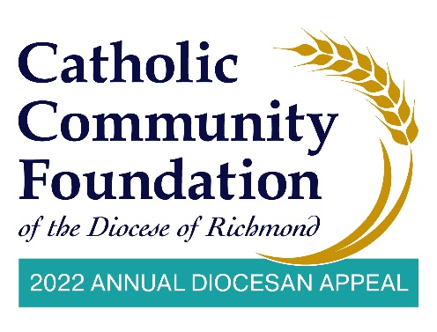

February 26-27 Announcement Weekend
Talking Points for Pastors

- The Annual Diocesan Appeal is upon us, and I find this year’s theme to be such a great reminder of what the Lord calls us to do. The theme is Together, We Bestow His First Fruits.

  - We are reminded to bring what we have first to the Lord which means our best offerings not what is left over.
  - The Appeal also unites our Church together in supporting our ministries that one parish cannot support alone and that moves our Church forward.

- I am so grateful for our <PARISH NAME> family. Together we have overcome unimaginable hurdles as we continue to make our way through the pandemic. Because of you, we were able to <PARISH SPECIFICS i.e. livestream mass, provide food assistance, etc.>
- As this year’s Appeal begins, I encourage each of you to support not only our parish offertory, which directly supports our parish, but I also ask you to prayerfully consider giving to the Annual Diocesan Appeal.

- Your gift to the Appeal makes a real difference because, together, we can enable our Diocese to deliver ministries and services such as heating and grocery assistance to families, health insurance for our retired priests, and tuition for our future priests to attend the seminary.
- We are so blessed at <PARISH NAME> because of the assistance of the Appeal. [List blessings and parish ministries supported by the Appeal. For example: We have a beautiful church, we have a great school, or we have a wonderful religious education program.]

- I know it’s not always easy to support the church, whether that is our parish or the diocese. I also want you to know that it’s not always easy for me to stand up here and ask you week after week. But please know the importance of what the Appeal is doing and the impact it’s making in the lives of others.

- During this Appeal season, many of you received a letter from Bishop Knestout, and I ask you to read through it closely and reflect on how we can help him fulfill his mission and, together, share our first fruits.

- Over the last two years the use of technology and online tools have accelerated. The Annual Appeal has been a beneficiary of this as people can now make their contributions more securely and efficiently than ever before.

- To this point, I would encourage you to scan the QR code you see in the pews or visit https://richmondcatholicfoundation.org/appeal/ if you have not yet already made your gift this year.

- If you have any questions at all about the Appeal, or how to adjust your online
giving, there is a phone number below the QR code so please reach out, they are
an easy call away if you have questions. <PARISH CONTACT NAME> at the
Parish office is also available to help as needed. In advance, make sure to provide the Parish office with Faith Direct’s phone number and email if additional help is needed: 866-507-8757 or info@faithdirect.net.

- We look forward to all of you helping us make this year’s Appeal a success.

