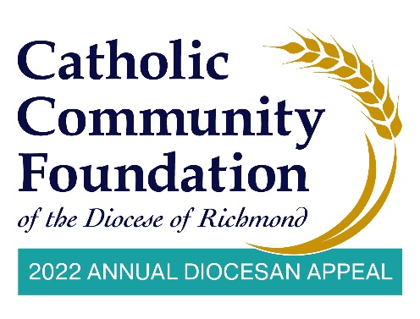
In-Pew Weekends: March 5-6 & 12-13
Talking Points for Pastors

- In-Pew Weekend is here! I hope you have taken time to consider how you and your family can support this year’s Annual Diocesan Appeal, which helps to empower the next generation, provide for those in need, and strengthen Catholic communities in many important ways.

- Our goal as a parish this year is <$AMT> and I hope you will join me in helping to meet and exceed this year’s goal!

- There is so much need and we’re blessed at <PARISH NAME> to receive assistance from the Appeal. [List the blessings and parish ministries supported by the Appeal. For example: We have a beautiful church, we have a great school, or we have a wonderful religious education program.]

- I know it’s not always easy to support the church, whether that is our parish, or the diocese and I know it’s not always easy for me to stand up here and ask you week after week.

- But please know the importance of what the Appeal is doing and the impact it’s making in the lives of others.

(Continues on next page)

- Over the last two years our lives have shifted online. For instance, we continue to livestream Mass, which is a blessing to reach those who cannot join us in person, provide virtual classes, and reach many through social media. I’ve spoken with more people over Zoom in the last year than I have over the phone! We are used to using technology is so many areas of life and we will rely on technology once again – this time for our support of the Appeal.

- We once again have a secure and convenient way to make your 2022 Appeal commitment online by using the QR Code that is taped in the pews.
  - For those in the pews, tape the QR code on the backs of the seats or pews. It is not required to have them at every seat. You can spread them out. The idea is just to make sure people can see them easily from where they are sitting.
  - At this time, the digital usher puts up the website on the livestream so people can see the address.

- Now, I know I usually encourage that we set aside our phones and distractions, but you can use it right now to support the much-needed ministries of our parish and our diocese.

- If you have any issues with the QR Code, the web address is https://richmondcatholicfoundation.org/appeal/

- You’ll be able to make an ongoing recurring gift, a 12-month pledge, or a one-time gift. That website again is https://richmondcatholicfoundation.org/appeal/.
- There is also a phone number for you to call if you have any issues making a contribution online or prefer to make your contribution over the phone. I would encourage you to take a photo of the phone number or write it down.

(Continues on next page)
- Note that we will post a brief video on our parish website and in the comments section of our livestream that walks you through how to make your contribution conveniently online.

- At this time, the digital usher or the person who manages your social media/livestream puts up the online giving tutorial on the livestream so people can access it if they need help filling out the form.

- The collective spirit we bring to this effort today will be a major step to our success with this year’s Appeal. Keep in mind: the more we collect, the more we receive back through the parish sharing formula of the Appeal.

- At this time, we would like to pause for about five minutes so anyone who has not yet given can go online and make their pledge or gift.

- If you have already given, thank you very much. During these five minutes, perhaps you could offer prayers for the success of this year’s Appeal.

- PAUSE FOR FIVE MINUTES.

- After five minutes: Thank you for taking the time to fill out the online form and for supporting this year’s Appeal. We look forward to updating you on our Appeal progress soon. God bless.

