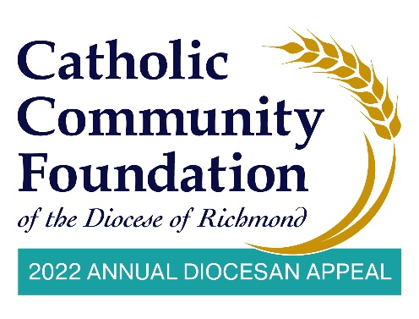
February 26-27 Announcement Weekend - Email from Pastors to Parishioners

I love the beginning of a new year. It brings a sense of hope as it is a time for fresh starts and big plans.

Since the start of this pandemic, we have all been given more time for pause and reflection, and I found myself continuously thinking of our <PARISH NAME> family. Despite the obstacles our parish faces because of the pandemic, you have kept our parish moving forward. For that, I thank you.

I know there are a million things pressing for your attention, and so many worthy causes that you can support. With this email, I want to focus on one important cause and that is the 2022 Annual Diocesan Appeal.

You may not realize this, but we are so blessed at <PARISH NAME> because of the assistance of the Appeal. I see what you do for our parish and your actions are reflective of this year’s Appeal theme “Together, We Bestow His First Fruits”. You are bringing your best to the Lord and that has allowed us to [List the blessings and parish ministries supported by the Appeal. For example: have a beautiful church, have a great school, or have a wonderful religious education program.]

You have likely received a letter and brochure from Bishop Knestout regarding the 2022 Appeal. I would ask you to please take a moment to reflect on all the ministries the Appeal supports and prayerfully consider a new gift or an increase in your gift if you have contributed previously. While you are praying on your gift, please also consider giving online. You can do so at https://richmondcatholicfoundation.org/appeal/.

I truly believe that we have the opportunity for a fresh start this year and the opportunity to support what we feel is most important. I know you feel this parish and our diocese are important – thank you for reflecting that in your level of giving.

If you have any questions at all about the Appeal, or how to adjust your online giving, please reach out to <PARISH CONTACT NAME> at <PHONE NUMBER > or <EMAIL ADDRESS>.

You and your family are in my prayers, and I hope that I am in yours.

Gratefully in Christ,
<INSERT SIGNATURE>
<PASTOR NAME>
<PASTOR TITLE>

