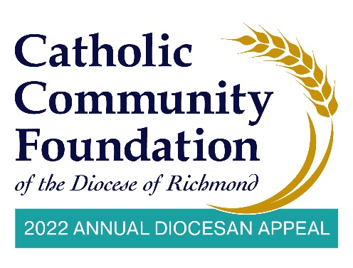
March 19-20 Post In-Pew Weekends
Talking Points for Pastors

- The last couple of weekends I have spoken about the Annual Diocesan Appeal. I hope you have taken time to consider how you can support this year’s effort which delivers ministries to those seeking to expand their faith and education as well as provides essential ministries throughout our Diocese.

- I am pleased to tell you that we are % of 2022 Parish Target towards our parish goal of $2022 Parish Target with $Total Raised. If you have not yet made a commitment, I hope you will join me in helping to not only meet but exceed this year’s goal!

- Over the last two years the use of technology and online tools has accelerated. The Annual Appeal has been a beneficiary of this as people can now make their contributions more securely and efficiently than ever before.

- To this point, I invite you to use your phone to scan the QR code you see in your pew or go to https://richmondcatholicfoundation.org/appeal/ where you’ll be able to make an ongoing recurring gift, a 12-month pledge, or a one-time gift. That website again: https://richmondcatholicfoundation.org/appeal/.
- Note that we have a brief video on our parish website that shows you how to make your gift online. We will post it in the comments section of our livestream.

- At this time, the digital usher or the person managing social media puts up the online giving tutorial on the livestream so people can access it if they need help filling out the form.

(CONTINUES ON NEXT PAGE)

- If you have any questions at all about the Appeal, or how to adjust your online
giving, there is a phone number below the QR code so please reach out, they are
an easy call away if you have questions. <PARISH CONTACT NAME> at the
Parish office is also available to help as needed. In advance, make sure to provide the Parish office with Faith Direct’s phone number and email if additional help is needed: 866-507-8757 or info@faithdirect.net.

- Thank you for your support!

