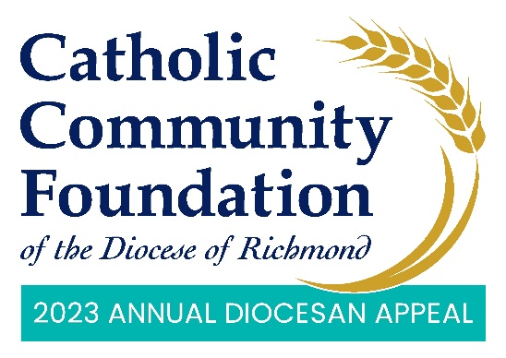

Announcement Weekend: February 18th and 19th
Talking Points for Pastors

- The Annual Diocesan Appeal is upon us, and I find this year’s theme to be such a great reminder of what the Lord calls us to do. The theme is Sharing His Love with Others.

  - Your continued generosity to the Annual Diocesan Appeal and your faith in our ministries are proof that by offering the Lord what we can, He will provide what we need.

  - The way the Lord shows His love through you reminds us that we are united as one Church, to come together and support our ministries as they provide for each of us.

- I am so grateful for our <PARISH NAME> family. Together we are creating a caring parish community that shares its resources with those in need of God’s love. Because of you we were able to <PARISH SPECIFICS i.e. livestream Mass, expand a ministry, come together for a special project, provide food assistance, etc.>
- As this year’s Appeal begins, I encourage each of you to support not only our parish offertory, which directly supports our parish, but I also ask you to prayerfully consider giving to the Annual Diocesan Appeal.

- The Appeal delivers ministries to those seeking to expand their faith and education, as well as provides essential ministries throughout our Diocese.
- We are so blessed at <PARISH NAME> because of the assistance of the Appeal. [List blessings and parish ministries supported by the Appeal. This may include the funds received back through parish sharing or you could talk about how your parish benefits from the larger Appeal case for support. It can also be both.]

- I want you to know the real difference of what the Appeal is doing and the impact it’s making in the lives of others. That is why I endorse the Appeal and why I hope you will as well.

- Earlier this year, many of you received a letter from Bishop Knestout about the Appeal and I ask you to read through it closely and reflect on how we can help him fulfill his mission and, together, share God’s love with others.

- Over the last few years, we seem to have accelerated the use of technology and online tools with donations to the Appeal happening more often online. I would encourage you to scan the QR code in the pews or on the pledge card or visit https://richmondcatholicfoundation.org/appeal/ if you have not yet already made your pledge or gift this year.

- If you have any questions about giving online to the Appeal, I encourage you to reach out to the Diocese’s e-giving vendor GiveCentral as they are the processor for all online Appeal donations. For your convenience, their phone number is below the QR code. <PARISH CONTACT NAME> in the
parish office is also available to help as needed.

  - In advance, make sure to provide the parish office with GiveCentral’s phone number and email if additional help is needed: (833) 716-2612 or support@givecentral.org.

