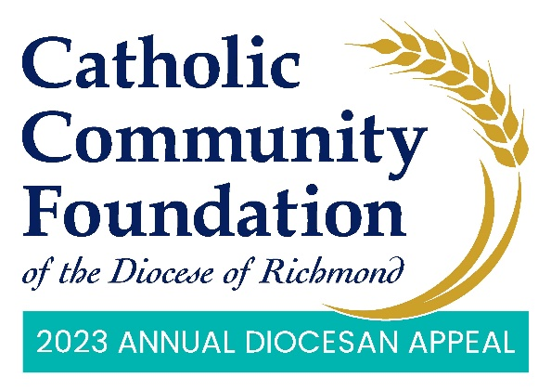

In-Pew Weekends: February 25-26 & March 4-5
Talking Points for Pastors

- In-Pew Weekend is here! I hope you have taken time to consider how you and your family can support this year’s Annual Diocesan Appeal, which helps to empower the next generation, provide for those in need, and strengthen Catholic communities in many important ways.

- Our goal as a parish this year is <$2023 Parish Target> and I hope you will join me in helping to meet and exceed this year’s goal!

- There is so much need and we’re blessed at <PARISH NAME> to receive assistance from the Appeal. [List blessings and parish ministries supported by the Appeal. This may include the funds received back through parish sharing or you could talk about how your parish benefits from the larger Appeal case for support. It can also be both. This is also a good time to emphasize the theme of the Appeal: Sharing His Love with Others.]

- Ultimately, I want you to know the real difference of what the Appeal is doing and the impact it’s making in the lives of others. That is why I endorse the Appeal and why I hope you will as well.

- Now, looking at your phone in church is not something I particularly endorse, however, this weekend I think it’s important to make an exception. Through your phone, you can make a pledge or gift right now to the Appeal just as easily and securely as making a purchase through Amazon.

- In the pews you will see the QR code that gives you access to the 2023 Appeal website. All you need to do is open your camera on your phone, hover it over the QR code, and then you should see a notification on your phone. Tap on that and you will see the 2023 Annual Appeal website. Once there, click on “Donate Now” – the big red button that is right at the top.

  - In preparation for this part of the presentation, you will want to tape the QR code on the backs of the seats or pews. You don’t have to do every seat and you can spread them out – you will just want to make sure people can see them easily from where they are sitting.
  - At this time, if you are doing a livestream Mass as well, the digital usher puts up the website on the livestream so people can see the address.

- If you are having issues with the QR Code, you can access the same page by typing into your internet browser: richmondcatholicfoundation.org/appeal/

- You’ll be able to make an ongoing recurring gift or a one-time gift. That website again is richmondcatholicfoundation.org/appeal/
- For your convenience, there is also a phone number for GiveCentral, the Diocese’s new Appeal online giving provider, on the same sheet as the QR code. If you are having issues contributing online or prefer to make your gift over the phone, you may contact them, and they can help walk you through it.

- Note: when you arrive at the GiveCentral giving page, there should be a box at the very top that says “Select Language”. If you click on the drop-down and click on “Spanish”, the page will auto-translate to Spanish.
- The collective spirit we bring to this effort today will be a major step to our success with this year’s Appeal. Keep in mind: the more we collect, the more we receive back through the parish sharing formula of the Appeal.

- At this time, we would like to pause for about five minutes so anyone who has not yet given can go online through their phones and make their pledges or gifts.

- If you have already given, thank you very much. During these five minutes, perhaps you could offer prayers for the success of this year’s Appeal.

- PAUSE FOR FIVE MINUTES.

  - To help pass the time for this section, you may want to consider playing some soft music while people complete their online donations.

- After five minutes: Thank you for taking the time to fill out the online form and for supporting this year’s Appeal. We look forward to updating you on our Appeal progress soon. God bless.

