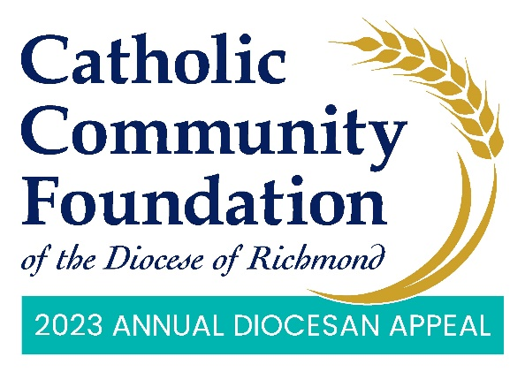

March 11-12 POST-In-Pew Weekend
Talking Points for Pastors

- The last couple of weekends I have spoken about the Annual Diocesan Appeal. I hope you have taken time to consider how you can support this year’s effort which delivers ministries to those seeking to expand their faith and education as well as provides essential ministries throughout our Diocese.

- I am pleased to tell you that we are % of 2023 Parish Target towards our parish goal of $2023 Parish Target with $Total Raised. If you have not yet made a commitment, I hope you will join me in helping to not only meet but exceed this year’s goal!

- I’d invite you to use your phone to scan the QR code located in the pews or on the pledge cards or go to richmondcatholicfoundation.org/appeal/ where you’ll be able to make an ongoing recurring gift or a one-time gift. That website again: richmondcatholicfoundation.org/appeal/
- If you have any questions about giving online to the Appeal, I encourage you to reach out to the Diocese’s e-giving vendor GiveCentral as they are the processor for all online Appeal donations. For your convenience, their phone number is below the QR code. <PARISH CONTACT NAME> in the
parish office is also available to help as needed.

  - In advance, make sure to provide the parish office with GiveCentral’s phone number and email if additional help is needed: (833) 716-2612 or support@givecentral.org.

- Thank you for your support!

