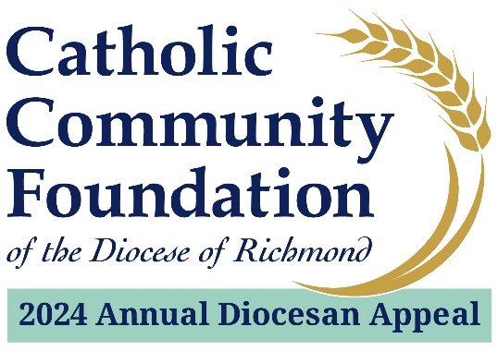

Announcement Weekend: February 10th and 11th
Talking Points for Pastors

- Since the middle of January, you have been hearing from us about the 2024 Annual Diocesan Appeal: Sharing His Love with Others.

- I find this year’s theme to be such a great reminder of what the Lord calls us to do. [Expand on what this theme means to you and to your parish.]

- Your continued generosity to the Appeal and your faith in our ministries are proof that by offering the Lord what we can, He will provide what we need.

- It is with this in mind that I hope each of you will prayerfully consider supporting the 2024 Annual Diocesan Appeal.

- Your support of the Appeal provides for twenty-two distinct ministries of our Catholic Church such as food and shelter for families, support for young men as they study to become our future priests, faith formation for youth and young adults, and so much more.
- We are so blessed at <PARISH NAME> because of the assistance of the Appeal. [List parish ministries supported by the Appeal. This may include the funds received back through parish sharing or you could talk about how your parish benefits from the larger Appeal case for support. It can also be both.]

- I want you to know the real difference of what the Appeal is doing and the impact it’s making in the lives of others. That is why I endorse the Appeal and why I hope you will as well.

- Recently, many of you received a letter from Bishop Knestout asking for your support of the 2024 Appeal. We hope you will prayerfully consider this request.

- For those of you who did not receive a mailing or have not had time to respond to it, we will conduct our In-Pew Process at all Masses during the weekends of February 17th/18th and February 24th/25th.

- On behalf of Bishop Knestout and <PARISH NAME>, thank you in advance for your support of the 2024 Appeal.

