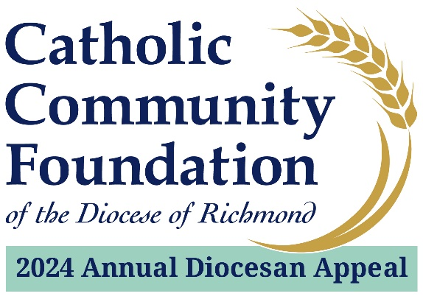

March 2-3 POST-In-Pew Weekend
Talking Points for Pastors

- The last couple of weekends I have spoken about the Annual Diocesan Appeal. I hope you have taken time to consider how you can support this year’s effort which provides essential ministries throughout our Diocese aimed at empowering the next generation of Catholics, helping those in need, and strengthening our parishes and Catholic communities.

- I am pleased to tell you that we are % of 2024 Parish Target towards our parish goal of $2024 Parish Target with $Total Raised. If you have not yet made a commitment, I hope you will join me in helping to not only meet but exceed this year’s goal!

- If you have not yet had the opportunity to contribute to the Appeal, or if you would like to make an additional contribution, I invite you to use your phone to scan the QR code located in the pews or go to richmondcatholicfoundation.org/appeal/ where you’ll be able to make an ongoing recurring gift or a one-time gift. That website again: richmondcatholicfoundation.org/appeal/

- We also have hard copy pledge cards available (mention where they may be found in the sanctuary – ideally, they are conveniently located in the pews).

- On behalf of Bishop Knestout, myself, and our parish leadership, thank you for supporting the 2024 Annual Diocesan Appeal. We look forward to updating you on our Appeal progress soon. God bless.

