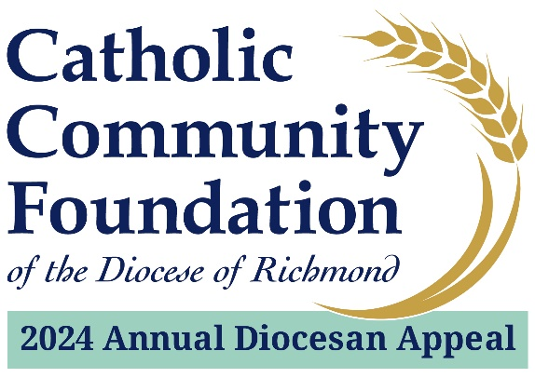

Presentation Script for In-Pew Weekends
February 17 – 18 / February 24 – 25, 2024
This weekend we are conducting the 2024 Annual Diocesan Appeal – Sharing His Love with Others. The Appeal not only provides an opportunity for you to support important ministries that impact many programs outside of our parish boundaries, it also supports the services the Diocese provides directly to our parish such as Fuel and Hunger Fund grants and youth and young adult ministry. You may expand using other examples. The entire list of ministries supported by the 2024 Appeal can be found in the brochures located throughout the pews.
In addition, our parish receives back a portion of the funds collected. This year, the funds returned will be used to Highlight specific parish projects that will be addressed with 2024 ADA rebate funds.
I want you to know the real difference of what the Appeal is doing and the impact it’s making in the lives of others. That is why I endorse the Appeal and why I hope you will as well. It is my hope that every household in our parish contributes to this year’s effort.
Our portion of the overall goal here at Parish Name is 2024 Parish Goal. Every gift, no matter the amount, makes a difference.
The collective spirit we bring to this effort today will be a major step to our success with this year’s Appeal. Keep in mind: the more we collect, the more we receive back through the parish sharing formula of the Appeal.
This year, there are two ways you can complete your gift intentions. The first is online.

In the pews you will see the QR code that gives you access to the 2024 Appeal website. All you need to do is open your camera on your phone, hover it over the QR code, and then you should see a notification on your phone. Tap on that and you will see the 2024 Annual Appeal website. Once there, click on “Donate Now” – the big red button that is right at the top.
  - In preparation for this part of the presentation, you will want to tape the QR code on the backs of the seats or pews. You don’t have to do every seat and you can spread them out – you will just want to make sure people can see them easily from where they are sitting.
  - At this time, if you are doing a livestream Mass as well, the digital usher puts up the website on the livestream so people can see the address.
If you are having issues with the QR Code, you can access the same page by typing into your internet browser: richmondcatholicfoundation.org/appeal/
You’ll be able to make an ongoing recurring gift or a one-time gift. That website again is richmondcatholicfoundation.org/appeal/
If you would prefer to contribute through a hard copy pledge card, those are attached to the brochures you will find in the pews (they are located in 2024 Appeal envelopes).
Before we give everyone the opportunity to support the 2024 Appeal, I want to make special mention of contributing through a recurring gift. Over the past few years, we have found that this type of giving is truly the best option for giving to the Appeal.
If you’re not familiar with recurring giving, it essentially means that you can conveniently set up an automatic monthly donation to the Appeal and it goes on until you decide to stop.
Over the past few years, we have seen significant increases in the number of donors taking advantage of this opportunity which has led to increased generosity for the Appeal (which means parishes are receiving more back for their local priorities). I hope you will consider this as a viable option for your giving.
Whether you are contributing online or with a hard copy pledge card, we would now like to pause for about five minutes, so everyone has the opportunity to complete their gift or pledge intentions.

If you have already given, thank you very much. During these five minutes, perhaps you could offer prayers for the success of this year’s Appeal.
PAUSE FOR FIVE MINUTES.
  - To help pass the time for this section, you may want to consider playing some soft music while people complete their online donations.
After five minutes:
At this time, if you filled out a card, please place your card into the envelope and seal it. The ushers will now come around and collect them.
On behalf of Bishop Knestout, myself, and our parish leadership, thank you for supporting the 2024 Annual Diocesan Appeal. We look forward to updating you on our Appeal progress soon. God bless.

