2024 Annual Diocesan Appeal – Sharing His Love with Others
Bulletin, E-Blast, and Pulpit Announcements

ANNOUNCEMENT FOR WEEKEND OF MAY 11/12

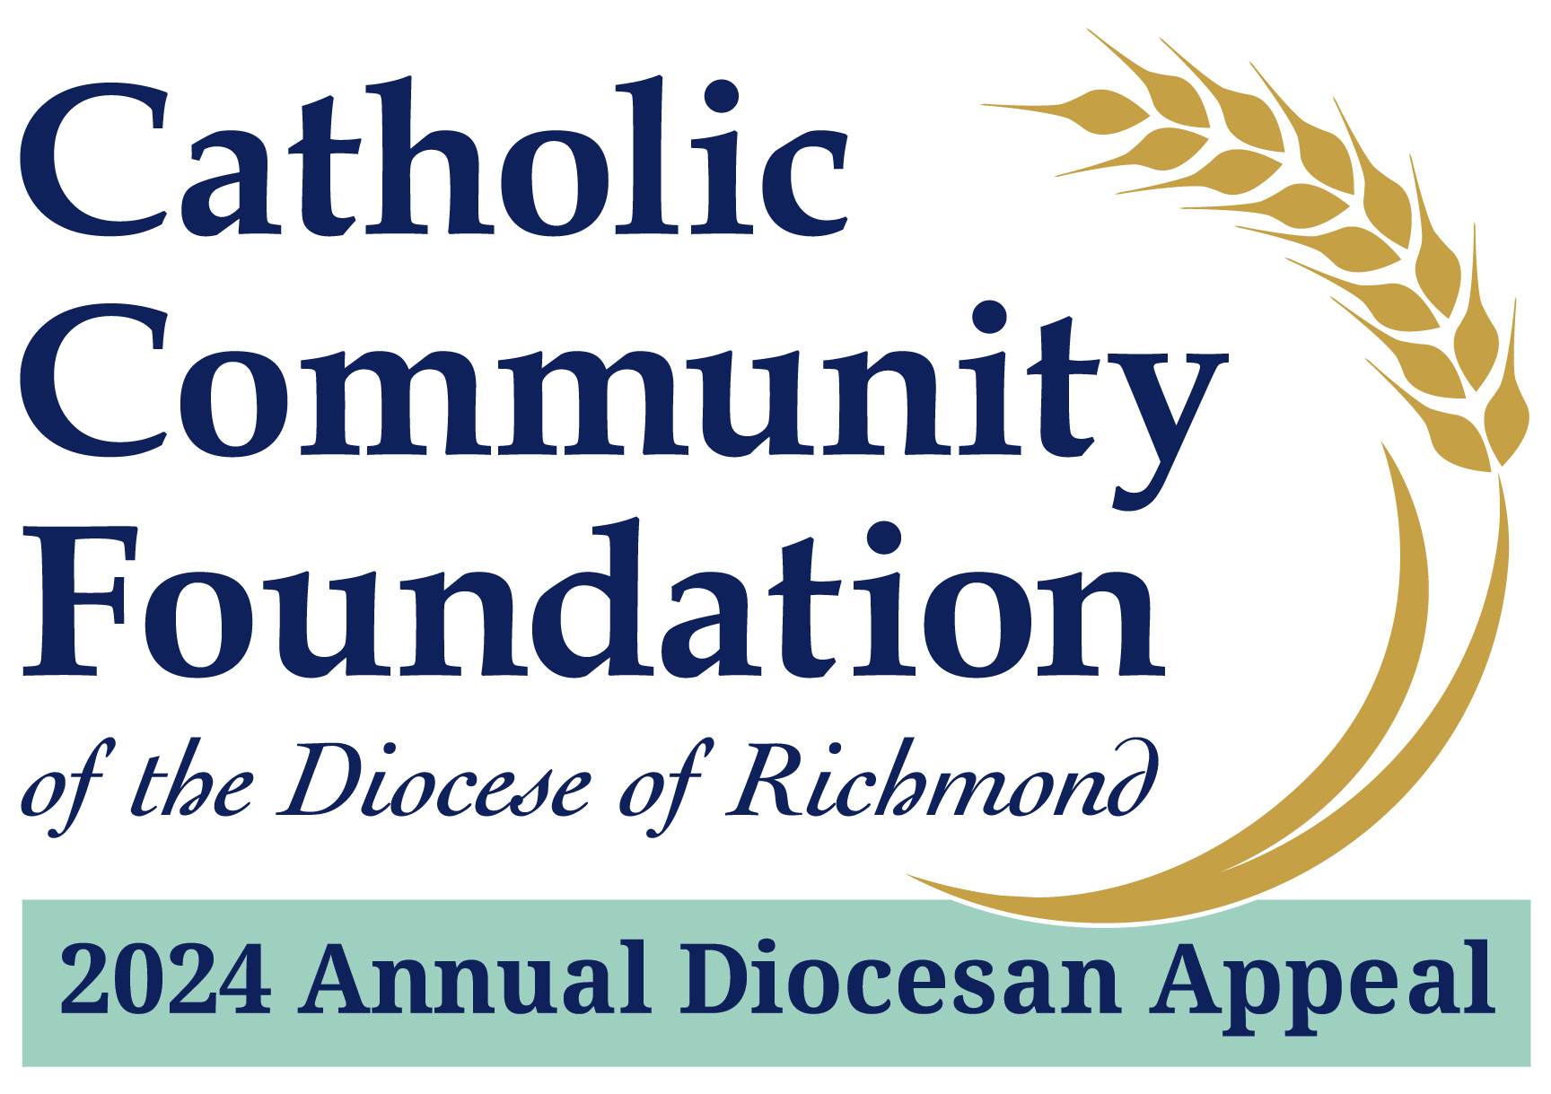

2024 Annual Diocesan Appeal:
Sharing His Love with Others
A Message from Fr./Msgr. Name
I want to provide a brief update on our 2024 Annual Diocesan Appeal effort at Parish Name. I am pleased to tell you that we are % of 2024 Parish Target towards our parish goal of $2024 Parish Target with $Total Raised.
It is my hope that every household in our parish contributes to this year’s effort. If you have not yet made a commitment, I hope you will join me in helping to not only meet but exceed this year’s goal!
Please visit richmondcatholicfoundation.org/appeal to make a secure online donation or visit our parish office for a hard copy pledge card. Every gift, no matter the amount, makes a difference. Thank you very much for your prayerful consideration of support. God bless.

ANNOUNCEMENT FOR WEEKEND OF MAY 18/19

2024 Annual Diocesan Appeal:
Sharing His Love with Others
A Message from Fr./Msgr. Name
Over the past couple of months, I hope you have gained an understanding of what it means to support the 2024 Annual Diocesan Appeal. Yes, our parish is a direct beneficiary, however, supporting the Appeal is also about supporting the Catholic Church beyond the parish. For example, did you know that the Appeal:
- Provides a variety of assistance to mission parishes such as funds for capital improvements, outreach ministries, and specific ministry costs.
- Provides formation opportunities for youth and young adults aimed at community building, prayer, worship, service, and education.
If you have not yet made a commitment, I hope you will join me in helping to not only meet but exceed this year’s goal!
Please visit richmondcatholicfoundation.org/appeal to make a secure online donation or visit our parish office for a hard copy pledge card. Thank you for partnering with us on this important ministry of our Catholic Church.

ANNOUNCEMENT FOR WEEKEND OF MAY 25/26

2024 Annual Diocesan Appeal:
Sharing His Love with Others
The purpose of the 2024 Annual Diocesan Appeal is to fund ministries which one parish cannot support alone. When we come together, we are able to educate all our seminarians, provide hundreds of thousands of dollars in grants to help those in need with basic necessities, and conduct the programs designed to build the next generation of Catholics.
When you step back and look at the Appeal’s case for support of not just these ministries but many others, it is amazing to realize the impact that each of us has on moving our Church forward.
YOUR gift matters.
Please visit richmondcatholicfoundation.org/appeal to make a secure online donation or visit our parish office for a hard copy pledge card. Thank you for partnering with us on this important ministry of our Catholic Church.

