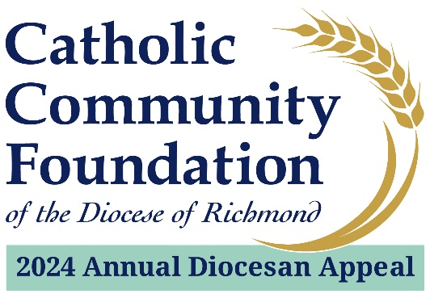

2024 Appeal - Parish Sharing Check Schedule
1st Round
Based on total collected as of 6/30/24
Checks sent to parishes by 7/29/24

2nd Round
Based on total collected as of 9/30/24
Checks sent to parishes by 10/31/24

3rd Round
Based on total collected as of 12/31/24
Checks sent to parishes by 1/31/25

4th Round
Based on total collected as of 3/31/25
Checks sent to parishes by 4/30/25

