2024 Annual Diocesan Appeal – Sharing His Love with Others
Bulletin, E-Blast, and Pulpit Announcements

ANNOUNCEMENT FOR WEEKEND OF JUNE 8/9

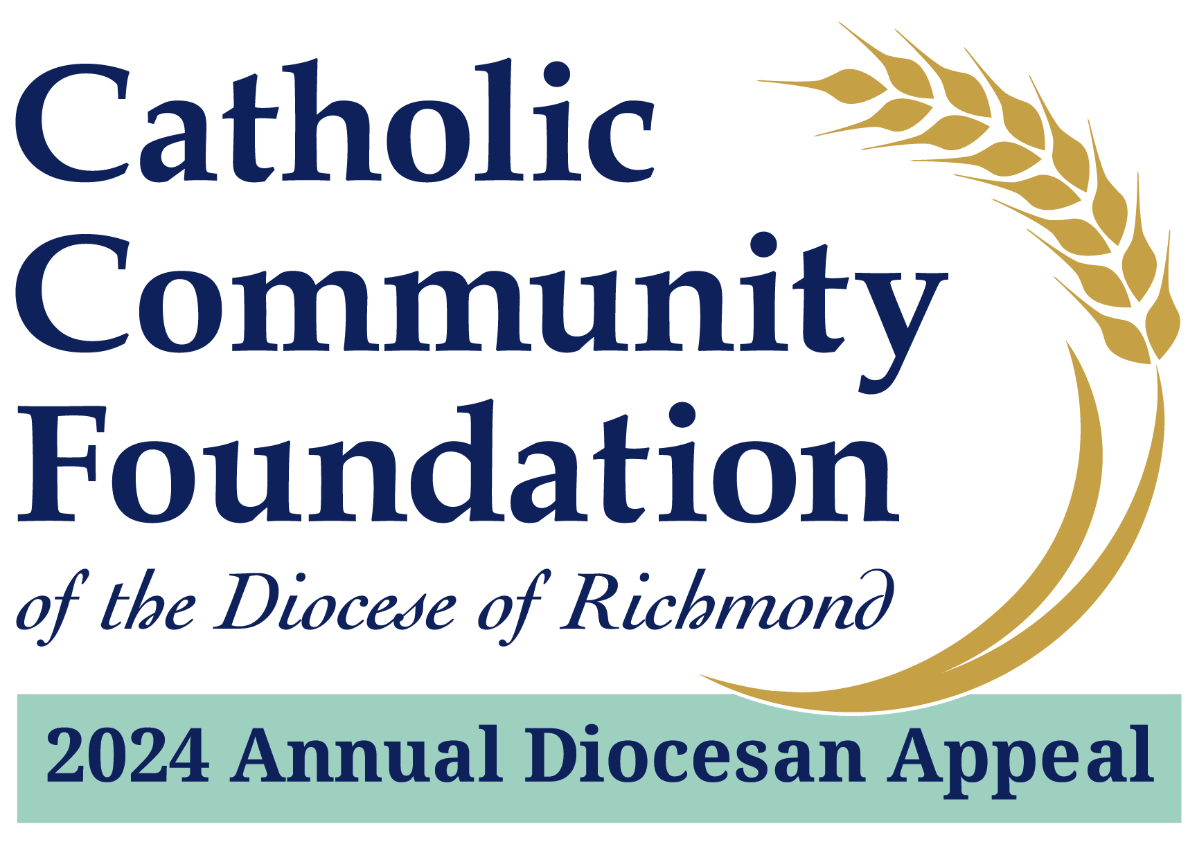

2024 Annual Diocesan Appeal:
Sharing His Love with Others
A Message from Fr./Msgr. Name
Supporting the 2024 Annual Diocesan Appeal is about supporting important ministries of our Catholic Church. For example, did you know that the Appeal:
- Funds the cost of room, board, tuition, and health insurance for our seminarians.
- Supplements health insurance and long-term care for our priests who have given their lives in service to the Church.
- Defrays the cost of providing ongoing professional, spiritual, and theological formation for our priests.
If you have not yet made a commitment, I hope you will join me in helping to not only meet but exceed this year’s goal!
Please visit richmondcatholicfoundation.org/appeal to make a secure online donation or visit our parish office for a hard copy pledge card. Thank you for partnering with us on this important ministry of our Catholic Church.

ANNOUNCEMENT FOR WEEKEND OF JUNE 22/23
2024 Annual Diocesan Appeal:
Sharing His Love with Others
A Message from Fr./Msgr. Name
I want to provide a brief update on our 2024 Annual Diocesan Appeal effort at Parish Name. I am pleased to tell you that we are % of 2024 Parish Target towards our parish goal of $2024 Parish Target with $Total Raised.
For many of you who have not yet had the opportunity to support the Appeal, you should have recently received a letter from me requesting your support of this year’s effort. I sincerely hope you will join me in helping to not only meet but exceed this year’s goal!
Please visit richmondcatholicfoundation.org/appeal to make a secure online donation or visit our parish office for a hard copy pledge card. Every gift, no matter the amount, makes a difference. Thank you very much for your prayerful consideration of support. God bless.

