2024 Annual Diocesan Appeal – Sharing His Love with Others
Bulletin, E-Blast, and Pulpit Announcements

ANNOUNCEMENT FOR WEEKEND OF JULY 20/21

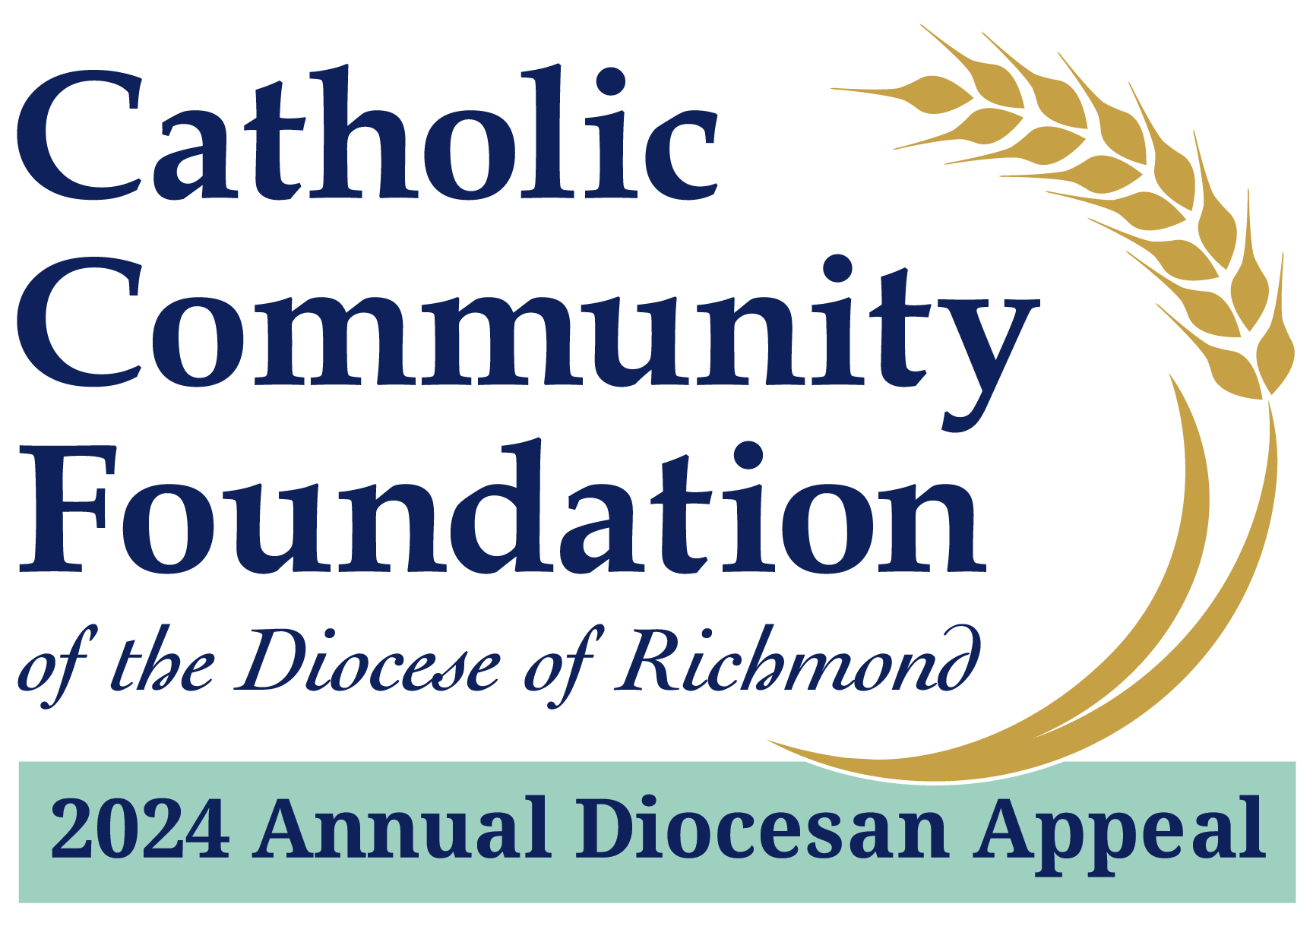

2024 Annual Diocesan Appeal:
Sharing His Love with Others
A Message from Fr./Msgr. Name
Supporting the 2024 Annual Diocesan Appeal is about supporting important ministries of our Catholic Church. For example, did you know that the Appeal:
- Expands opportunities for college students to deepen their commitment to the Catholic Church.
- Develops lay catechetical leaders by building theological understanding, shaping pastoral skills, and strengthening Catholic identity.
- Provides a variety of assistance to mission parishes such as funds for capital improvements, outreach ministries, and specific ministry costs.

If you have not yet made a commitment, I hope you will join me in helping to not only meet but exceed this year’s goal!
Please visit richmondcatholicfoundation.org/appeal to make a secure online donation or visit our parish office for a hard copy pledge card. Thank you for partnering with us on this important ministry of our Catholic Church.

