2024 Annual Diocesan Appeal – Sharing His Love with Others
Bulletin, E-Blast, and Pulpit Announcements

ANNOUNCEMENT FOR WEEKEND OF AUGUST 24/25

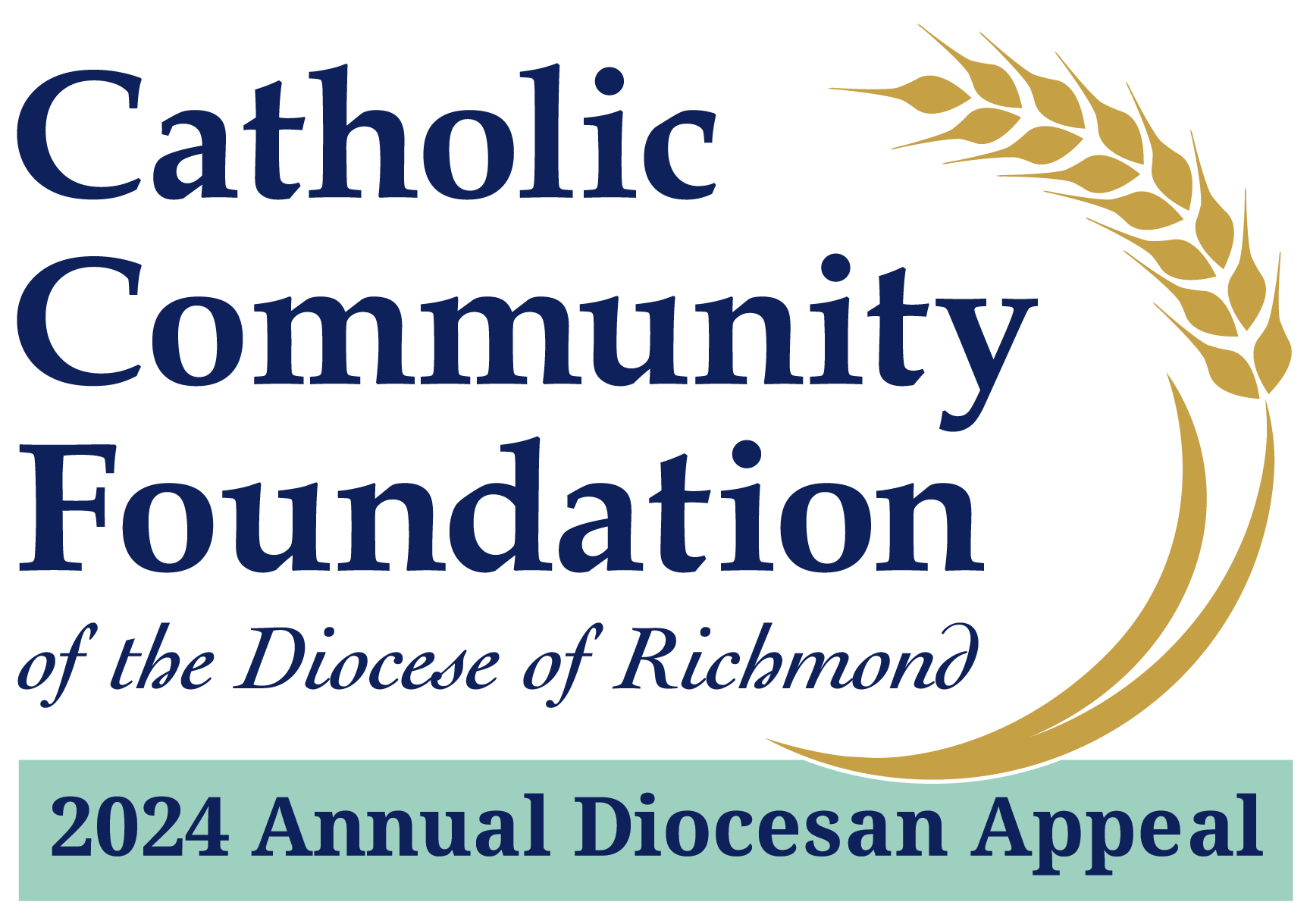

2024 Annual Diocesan Appeal:
Sharing His Love with Others
A Message from Fr./Msgr. Name
Supporting the 2024 Annual Diocesan Appeal is about supporting important ministries of our Catholic Church. For example, did you know that the Appeal:
- Supports the local needs of our parishes by returning a sizable portion of the dollars collected from the Appeal effort.
- Provides needed resources to St. Francis – Manchester, a Richmond-based facility to aid in their ongoing ministry of serving seniors and disabled adults who have little or no means of income.
- Offers stipends to bi-lingual Latino advocates who serve children in Catholic Schools.

If you have not yet made a commitment, I hope you will join me in helping to not only meet but exceed this year’s goal!
Please visit richmondcatholicfoundation.org/appeal to make a secure online donation or visit our parish office for a hard copy pledge card. Thank you for partnering with us on this important ministry of our Catholic Church.

