2025 Annual Diocesan Appeal – Sharing His Love with Others
Bulletin, E-Blast, and Pulpit Announcements

ANNOUNCEMENT FOR WEEKENDS OF JANUARY 18/19 & JANUARY 25/26
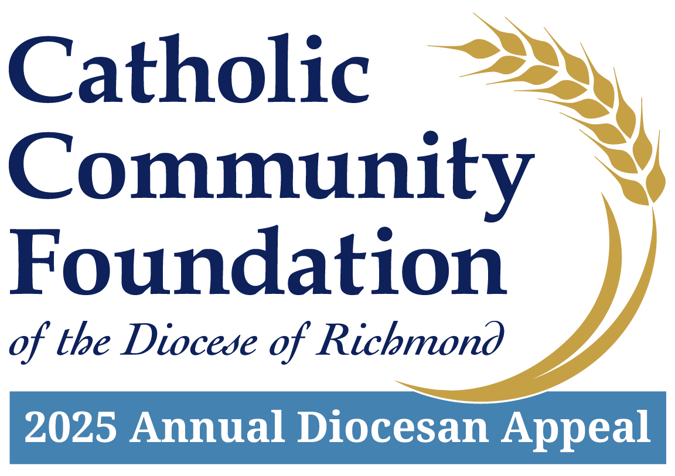
2025 Annual Diocesan Appeal:
Sharing His Love with Others
Welcome to the 2025 Annual Diocesan Appeal – Sharing His Love with Others.
The 2025 Appeal will provide critical funding to three key areas of our Diocesan Church: Empowering the Next Generation, Providing for Those in Need, and Strengthening Catholic Communities.
In addition, our parish receives back a portion of the funds collected. This year, the funds returned will be used to Highlight specific parish projects that will be addressed with 2025 ADA rebate funds.
In complement to the funds returned to our parish through the parish sharing formula, the 2025 Appeal also benefits us through the following ministries and programs. Share the assistance you receive from the larger Diocesan Case for Support such as Fuel and Hunger Fund grants, youth and young adult ministry, international priests who help lead our parishes, or the benefit of a seminarian who is stationed at your parish.

