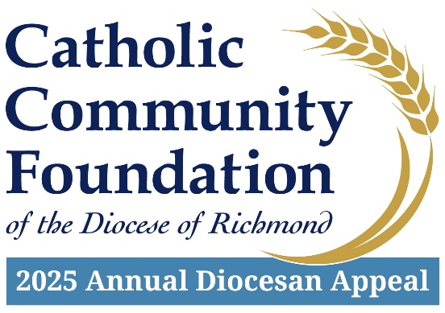

March 22-23 POST-In-Pew Weekend
Talking Points for Pastors

- The last couple of weekends I have spoken about the Annual Diocesan Appeal. I hope you have taken time to consider how you can support this year’s effort which provides essential ministries throughout our Diocese aimed at empowering the next generation of Catholics, helping those in need, and strengthening our parishes and Catholic communities.

- I am pleased to tell you that we are % of 2025 Parish Target towards our parish goal of $2025 Parish Target with $Total Raised.

- If you have not yet had an opportunity to support this year’s Appeal (or if you are still praying about your decision), I want to mention something important. That is the Annual Appeal helps fund cornerstone ministries of the Diocese of Richmond that one parish cannot support alone.

- For instance, one parish could not support the room, board, and tuition assistance needs of our seminarians, supply over half a million dollars to parish foodbanks and Catholic organizations across our Diocese or provide for diocesan-wide next generation evangelization and formation initiatives.

- The importance of the Annual Appeal to the life and ministry of our Catholic Church cannot be overstated. The faithful support of the Appeal by so many enables our Diocese to more effectively meet the urgent annual needs of the Church which serve as building blocks to grow the Church’s impact for years to come.

- If you would like to contribute, I invite you to use your phone to scan the QR code located in the pews or go to richmondcatholicfoundation.org/appeal/ where you’ll be able to make an ongoing recurring gift or a one-time gift. That website again: richmondcatholicfoundation.org/appeal/

- We also have hard copy pledge cards available (mention where they may be found in the sanctuary – ideally, they are conveniently located in the pews).

- On behalf of Bishop Knestout, myself, and our parish leadership, thank you for supporting the 2025 Annual Diocesan Appeal. We look forward to updating you on our Appeal progress soon. God bless.

